Generate the pgp file and convert it to .asc format for SUSE LINUX 12

Step1:login to server as root

#sudo –i

Step2:then move to directory /dev/null

#script /dev/null

Step3:run below command to gerenarate the key

#gpg2 --gen-key

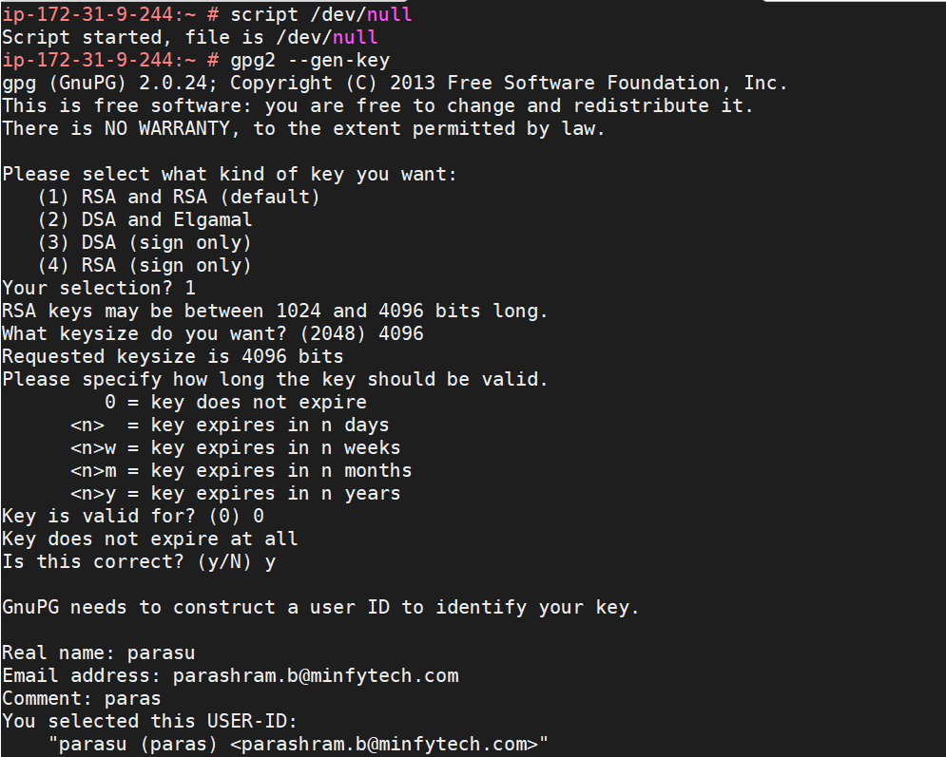

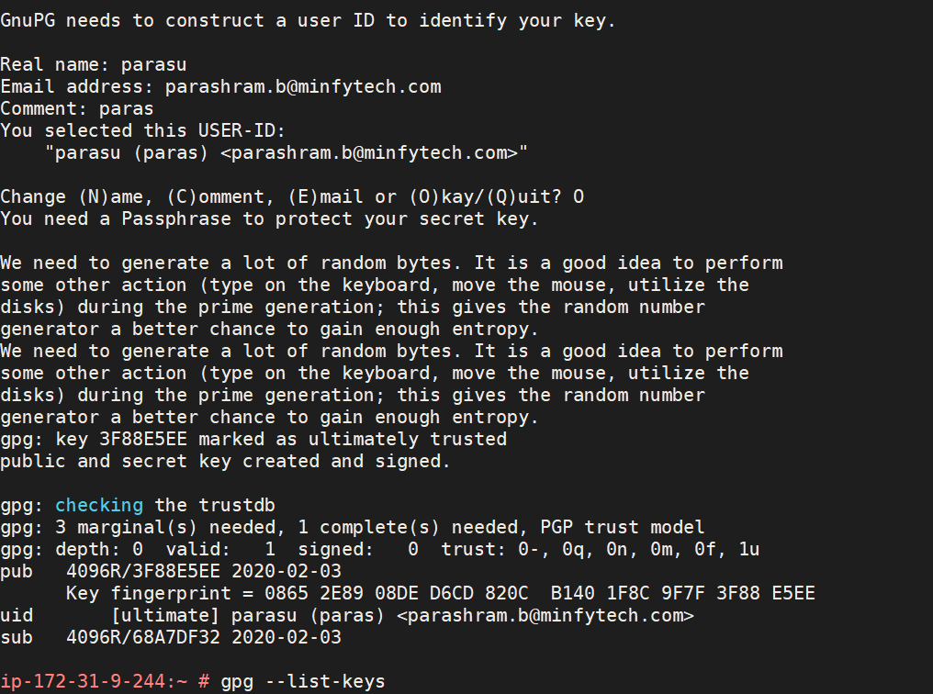

Once the key is generated then run the command

#gpg --list-keys

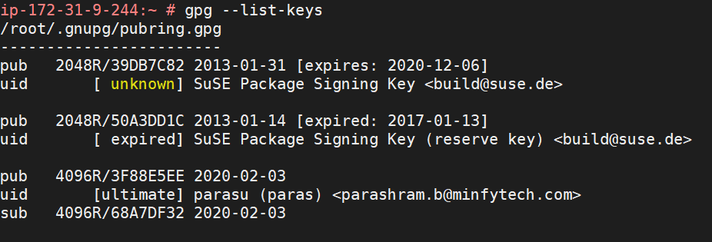

The key will be stored in /root/.gnupg folder

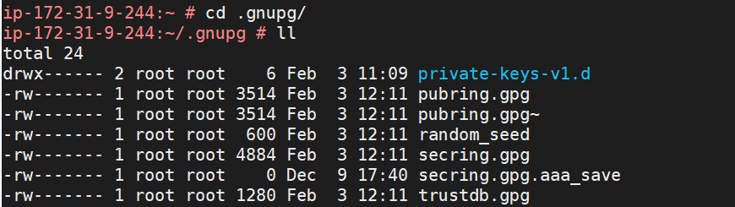

The pgp files have been generated.

The scecrate file can be separated by command

# gpg --list-secret-keys

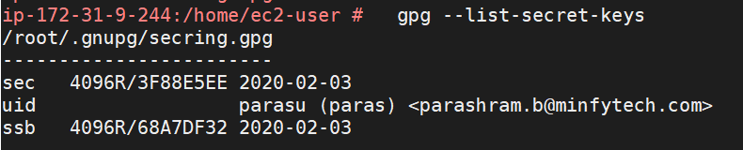

Export the pgp file into .asc format using the below cmd

# gpg --armor --export parashram.b@minfytech.com > pubkey1.asc

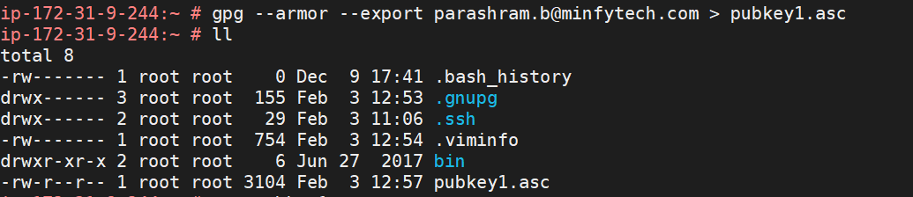

To see the pgp file

#cat pubkey1.asc

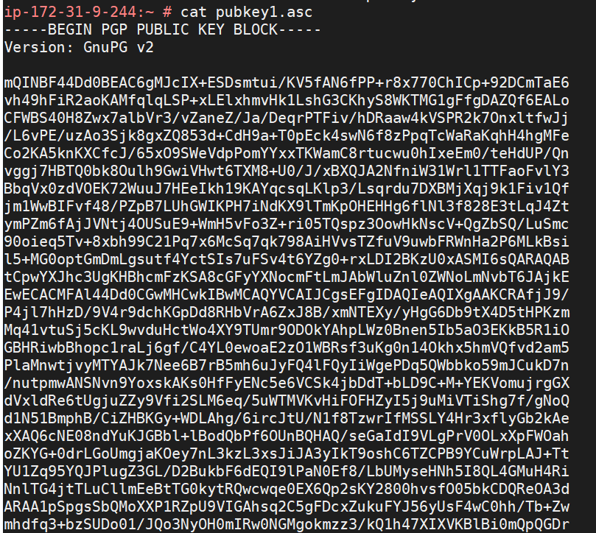

Links for more clarification.

<https://bugzilla.redhat.com/show_bug.cgi?id=659512>

<https://www.suse.com/c/gnupg-gnu-privacy-guard/>

<https://unix.stackexchange.com/questions/440978/how-do-you-generate-an-asc-file-from-pgp-public-key>

<http://wooledge.org/~greg/crypto/node41.html>